**The Select Query**



The above query will give all the data from the table.

**A Better SELECT**

Here’s a SELECT statement, where we use a **WHERE clause that gives the RDBMS something specific to search for.** It narrows down the result for us and **only returns the rows that match the condition.**

The equal sign in the WHERE clause is used to test whether each value in the column equals, or matches, the text given in the query.





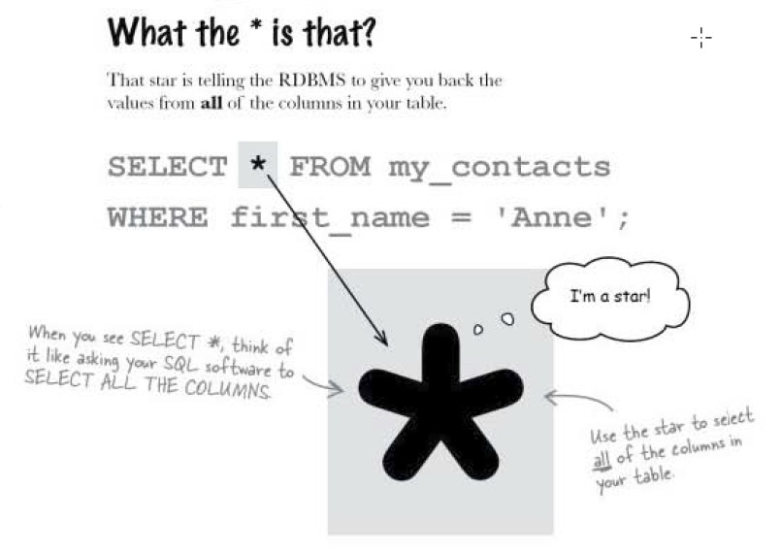

**Q: What if I don’t want to select all the columns? Can I use something else instead of the star?**

A: Yes you can. The star selects everything, but in a few pages you’ll learn how to just select some of the columns, making your results easier to interpret.

**Q: Is this star the same thing as an asterisk?**

**A:** Yes, it’s the same character on your keyboard located above the 8 key. Hit SHIFT at the same time as the * to type one. This is the same for Mac and PC users.

But , although it’s exactly the same character as asterisk, in SQL lingo, it’s always referred to as star.

**Q: Are there other characters that have special meanings like the star does?**

**A:** SQL does have other special, or reserved, characters. You’ll see more of these later in the book. But the star is the only one you need to know about for right now. It’s the only one used in the SELECT part of an SQL statement.



















**Q: Isn’t this the same thing as an apostrophe?**

**A:**  It’s exactly the same thing as an apostrophe. SQL assigns it a very specific meaning. However, it’s used to tell the SQL software that the data in between two of them is text data.

**Q: What data types need them?**

**A:** The text data types. Text data simply means the data is a VARCHAR, CHAR, and BLOB. OR TIMEDATE column. Anything that isn’t a number.

**Q: Do DEC and INT columns need them?**

**A:** No, Numeric columns have no spaces, so it’s easy to tell when the number ends and the next word in the statement begins.

**Q: So, it’s only used for text columns?**

**A:**  Yes, only trouble is, text columns have space. This causes problems when your data contains apostrophes. SQL doesn’t know how to tell difference between apostrophes. SQL doesn’t know how to tell the difference between an apostrophe within the column and one that tells it when the column begins or ends.

**Q: Couldn’t we make it easy to tell them apart by using a double quote instead of a single quote?**

**A:** NO, Don’t use double quotes in case you use SQL statements with a programming language (like PHP) later. You use “ in the programming language to say “this is where the SQL statement is” ; that way, single quotes are recognized as being part of that statement and not part of the programming language.



You need to tell your SQL software that your quote isn’t there to begin or end a text string, but that it’s part of the text string.

**Handle quotes with a backslash**



**Handle quotes with an extra single quote**

